BUSINESS PROPOSAL OF A BUSINESS NEEDS FOR DIGITALIZING MSME.

VIOLET INFOSYSTEMS | MUMBAI

PRESENTING FOR XYZ MANUFACTURERS.

Shah Shamsudheen

[Year]

**BUSINESS REQUIREMENTS DOCUMENTS**

**[BRD]**

**“Digitalizing MSME Suppliers”**

**XYZ Manufacturers**

**Add: ABC Building**

**Malad Street**

**Mumbai – IN**

|  |  |  |  |
| --- | --- | --- | --- |
| APPROVALS | | | |
| NAME | **DESIGNATION** | **NARRATION** | **DATE** |
| Name 1 | **Director** |  |  |
| Name 2 | **Category Mang** |  |  |
| Name 3 | **Product Mang** |  |  |
| Name 4 | **Sales Mang** |  |  |
|  |  |  |  |

TABLE OF Contents

**BUSINESS PROBLEMS.** 4

**Diagram of data-process** 5

**Solutions Overview.** 6

**Assumptions.** 8

**Risks.** 9

**In Scope.** 10

**Out Of Scope.** 10

**Requirements.** 11

# **BUSINESS PROBLEMS.**

A worldwide electronic devices manufacturing company, XYZ having issues with supplier management process, because currently their supplier information is kept in hard copy. So, they want to digitalize those information’s in-order to easy access. So, they can easily find the good and profitable products for company’s manufacturing.

Here concerned problems is listed as below;

1. Challenges faced while doing the supplier management process manually.

* Track a record for performing and not performing suppliers
* Not able to evaluate the supplier based on the defect products, quality etc.
* Not able to see the consolidated view for all the Proposal/Timeline/RFQ’s submitted by Suppliers.

2. System must provide the option for the Product Manager to ask for the prototype or sample for the customized product based on that final call will be taken.

3. System must be cable enough to provide the details of the past suppliers and feedback through which it will be easy for the requester to check whether buying materials from this supplier is worth or not.

4. This system must be cable of

a) Supplier Enrolment

b) Supplier Management

c) Re-Negotiate the supplier

# **Diagram of data-process**

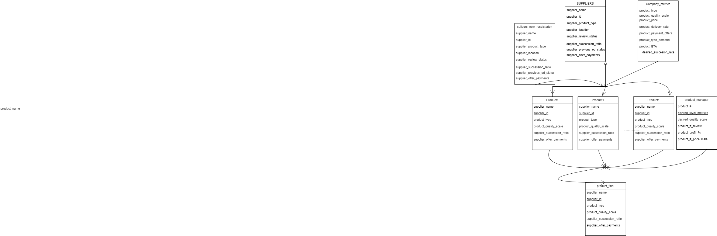

# **Solutions Overview.**

To solve this business problems, we have to invent or introduce new digital platform or web application that can be created using framework platform and Data Base Management Systems, Easiest one like Angular and DBMS like MySQL, Oracle DB and Microsoft SQL.

Here we have to create a web application that could useful to feed the information’s of existing supplier and if needed we have to register new supplier. Because according to the reports in the 2021 around 64 million enterprises are in India, which is second largest country-wise sector in world. Many of enterprises are unnoticeable, so by creating and marketing this platform will help us to find more MSME that may product exponential growth in our profit, quality of product and service & integrity.

As we know, Rolles Royce is a multi-million cost product, but from India they are only purchasing rubber bush for their mirror water-viper, even though in India we have 64 million MSME. Because they have access to million of billions MSME, so they can choose and purchase wisely in-order to maintain their quality of product, maintaining the profit and keeping the goodwill in the market.

Using the hard copies of supplier information’s, we can store those details as soft copies by using excel or SQL. By doing this we can store this data into DBMS and access in web application. In web application we can add some more metric/KPI’s regarding supplier’s, which will be useful further study like to determine whether supplier is performing-supplier or non-performing-suppliers. And check whether if there is any contract breach between supplier and company. Such metrics as given below;

* Interval scale for quality of service.
* Method of operation of service.
* Commitments towards the company.
* Completion of service by the given time interval.
* Succession ration (in%) depends on agreed terms.
* Adaptation of supplier’s or development progress of suppliers with forthcoming technologies

By calculating and measuring the such metrics, if supplier’s level of performance is less than the company desired level, we can determine that such suppliers is non-performing suppliers.

As we discussed before, using the DBMS like SQL servers and with help MS Excel or programming language like Python, Spyder we can create interlink between tables and our key requirement.

In SQL we can find out such linkage by create a primary table with company’s desired metrics and can find linkage with supplier’s data set as foreign tables. This linkage in SQL usually finds with ‘multiple function join’ function. And we can do this in web application.

Measuring the quality of products, by coordinating with product manager, discussing desired metrics which is suitable for company. Also, we can arrange an API in web application for product manager to finalize or making decision regarding the product for manufacturing. We can assign tested products and list finalized products which met company’s desired metrics and certain specification limits regarding all product, which is already provided by production manger regarding the specific products through process in web application.

By creating an API for users, we can collect the data from trusted consumers in-order to maintain stability of product, quality of the product and customer feedback about product. By adding this company can track what changes and implements are required in company products. Also, by associating with web designers who is been controlling wireframing can make conclusion about other requirements by users.

In other hand, we can also discuss/sampling survey about specification of products with common users (those one who always compare products with other products before making decision.) and selected users.

Also, we implement test process in web application in-order to check until which time we can cover the warranty of certain products, lifetime of certain products and how destructible are our products.

Since we are making web application in DBMS, we can access SAP data into web application using SAP cloud. By doing this we can access sales and profit of certain products. If specification metrics is created in SAP can be accessed in-order to finalize product before presenting to product manager.

# **Assumptions.**

By creating a web application, we can assume we can access to most of all MSME information and specification. In-order have this access we have to make sure most of all our MSME have registered with our application.

Also, we can assume while making soft copies of existing supplier’s information’s, there is no room for error in feeding information’s to the web application.

By doing this we can save investment on employees for tract functionality of supplier managements. Easly access to supplier by anytime and anywhere.

**EFFECT OF SYSTEM.**

We can access user requirements from 4th month

Complete data ETL in 2nd month

We can access supplier info as we desired.

Implementation in 1st month

In

Once we can full access and MSME in web app we can save money and reduce wastage and optimization will possible from 14th month

Within 12 months can have almost every MSME access

We can 95% confident that post test result optimization has significant effect in implementing web application, also by categorical hypothetical studies we can assume the past distribution of sales of product have increased.

# **Risks.**

First and most important we have made sure that our web application is supplier user friendly and easily accessible. Also, make sure that our suppliers are frequently filtering their information, if not there might be a chance selecting non-desirable product.

By creating a web application, we have risks that we have to ensure that nothing disturbance in flow of web application and we have to always make sure functionality of web application by test access speed using Weisman score.

Similarly, we have made sure in user’s API, real consumer are making feedback instead that if cheating happened we can’t know what requirements are wanted. Also, we make sure that our web application is user friendly to common consumer for marketing analysis. For that this part sales manager should give proper guide to our salesman

# **In Scope.**

Below mentioned will be covered.

1. Proper tracking of supplier functionality.
2. Tracking of quality of service of both supplier and product.
3. Finalizing the product by including the specification of product manager.
4. For MD, it is easy to arrange contract with suppliers, which include company’s particular criteria.
5. Determining company metrics clearly and choosing key Parameter Indicators.
6. Increasing the accessibility of product manager in more procedures.
7. Can filter new supplier and can find new offers quoted by suppliers.
8. Accessibility of sales manger using SAP software and do cross studies by including their metric in web application process.
9. Maximum utilization of resources.
10. Reduction in wasting resource.
11. Increase the profit exponentially.
12. Tracking quality maintenance.
13. Widening the scope of marketing.

## **Out Of Scope.**

Below mentioned will be covered.

1. Fraudulent in creating supplier information.
2. Limitation in product testing.
3. Needed some more hand in web application full stack, front end and back-end process during building time. Further their hand, may not be needed.

# **Requirements.**

1. Proper guidelines to the new suppliers and guidance to those who have already registration.
2. Maintaining contact with supplier administration to give them awareness about application continues updating.
3. Good wireframe programmed for make web application attractive and user friendly.
4. Cost of production and data entry operator.
5. Experience full stack developer.